Student Name: Weight: %
Student ID: Marks: /32

Assignment: Using CSS
In this assignment, you’ll demonstrate your ability to use CSS selectors using the best practices you learned in class. This assignment may be completed during a provided work period or outside of scheduled class time, as indicated by your instructor.

Instructions
- Working individually, create a CSS stylesheet to style an HTML website to match the sample pages at the end of this document.
- Upload the following to Brightspace:
- A link to your github pages site
- A link to your github repo that demonstrates:
- The provided HTML files linked to your CSS file.
- A styles folder containing your styles.css applying the styles as noted within.
- An images folder containing any required logos or pictures.
- An empty scripts folder.
- A screenshot showing the successful validation of your CSS from http://jigsaw.w3.org/css-validator/.
- Submit your assignment by the due date listed in Brightspace. See the marking criteria below for details on how you will be assessed.

Marking Criteria
 | 0 Marks | 1 Mark | 2 Marks | Marks
Content | HTML is not provided. | HTML has been modified. | HTML has not been modified. | /2
CSS Syntax and Formatting | No CSS is submitted. | CSS stylesheet is not correctly linked, or multiple stylesheets were created. | A single CSS file is correctly linked to both web pages. | /2
 | No CSS is submitted. | CSS has one or more errors in validation. | CSS passes validation with no errors. | /2
 | No CSS is submitted. | CSS contains inconsistent indentation, unnecessary blank lines, incorrect selectors or significant repetition within declarations. | CSS is well formatted, with minimal repetition. Appropriate and simple selectors have been used. | /2
Flexbox | Width calculations are absent from CSS declarations. | One or more width calculations are incorrect. | Width calculations are correct. | /2
 | Flexbox layout not used. | Flexbox layout used incorrectly. | Flexbox layout used correctly. | /2
Page Appearance | Page has no styled content. | Significant differences between submission and provided image. | Page is a reasonable replica of the provided image. | /10
Completeness | Fewer than 9 style items implemented. | 9 to 24 style items implemented. | More than 24 (out of 33) style items implemented. | /10
Total |  |  |  | /32

Sample Screenshots
Your completed pages should look similar to the following webpages.

Home Page
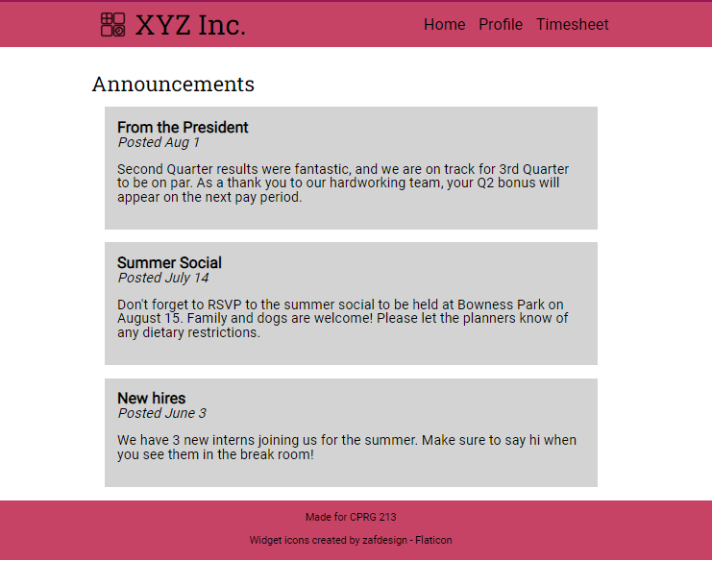
© 2022, Southern Alberta Institute of Technology

Profile Page
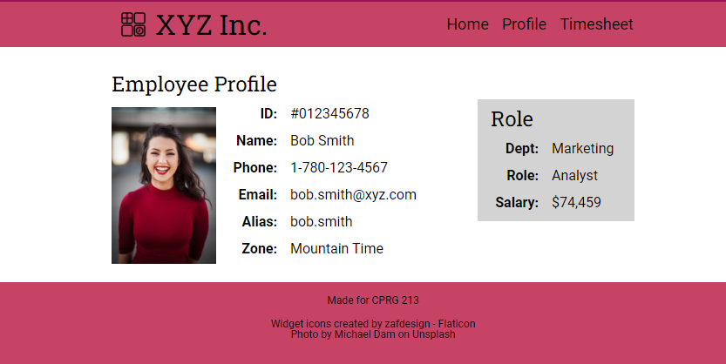

Timesheet Page
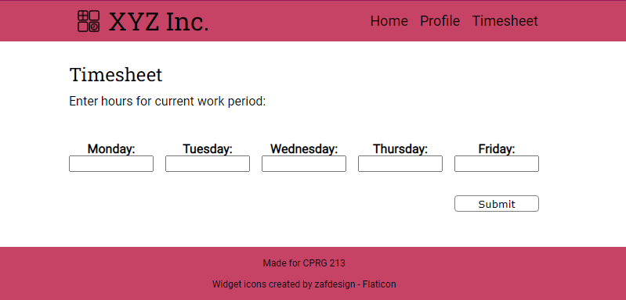
© 2022, Southern Alberta Institute of Technology

